Task 3 (1 and 2 have been done)

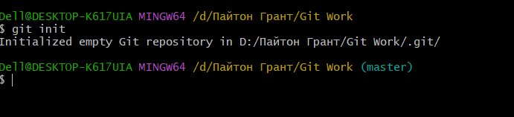

Task 4

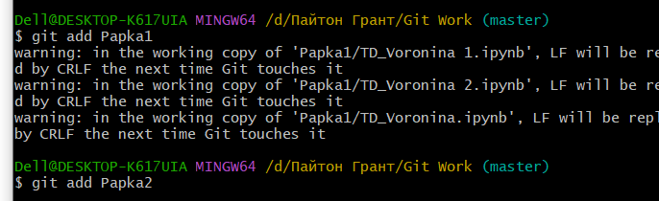

Task 5

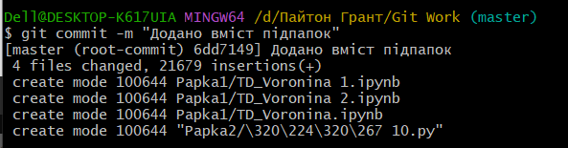

Task 6

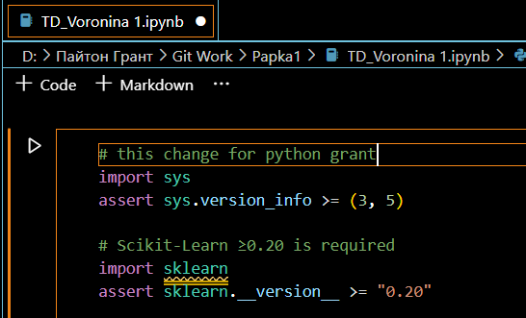

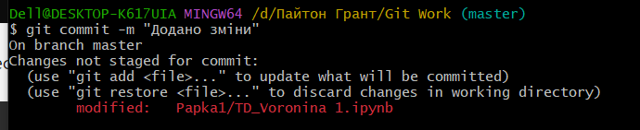

Task 7



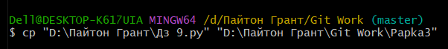

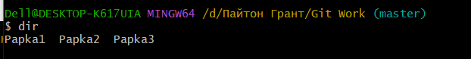

Task 8

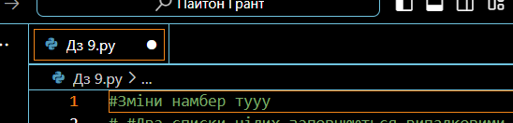

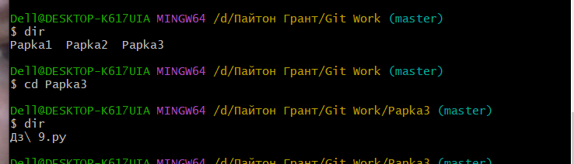



Task 9

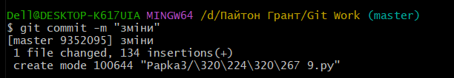



Task 10

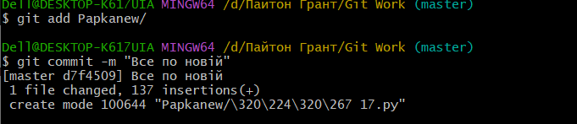 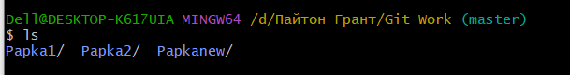

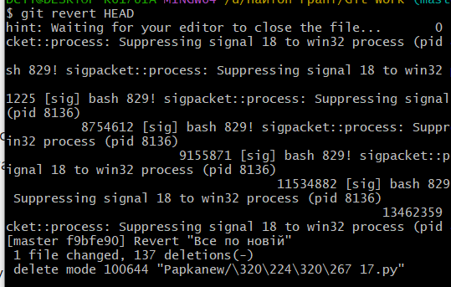

Task 11

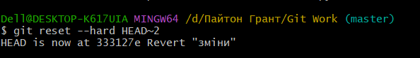

Task 12

